**Minimum Viable Product - Space Invaders Game Project**

* User stories of core features of the game:

1. As a user playing the game, I want to be able to move my spaceship left and right along the lower horizontal side of the canvas/window, so I can navigate my spaceship.
2. As a user playing the game, I want to be able to shoot projectiles from my spaceship, so that I can destroy enemy invaders.
3. As a user, I want to have *score* information displayed on the screen, so I know how good my gameplay has been in the current session.
4. As a user, I want to have *lives remaining* information displayed on the screen, so I know how many more times I can afford to be shot by invader projectiles before the game is over.
5. As a user playing the game (in-game scenario), I want to be able to access the game main menu interface, so that I can resume, restart, or quit the current game, or change the options of the game.
6. As a user about to play the game (new game scenario), I want to have an interface that will allow me to start a new game, change the options before starting a new game, and/or see the list of high scores.
7. As a user who wants to change game settings, I want to have a functional interface that will allow me to choose game difficulty, spaceship design, turn sound on/off, and/or change the background galaxy in the game.

* Programming paradigm I will use for this project is object-oriented programming (OOP).
* Library/API that I will use for this project is Canvas API for HTML/JS graphics drawing. The main reference for this project is this tutorial: https://www.youtube.com/watch?v=MCVU0w73uKI

The tutorial shows how to develop some of the game’s core functionalities and represents a software base on which I will build my own features for the game.

The programming environment I am using for this project is Code - OSS on Linux (Linux version of VS Code).

* User Interface sketches and the main menu wireframes:

Main menu user interface (at start of game and in-game)

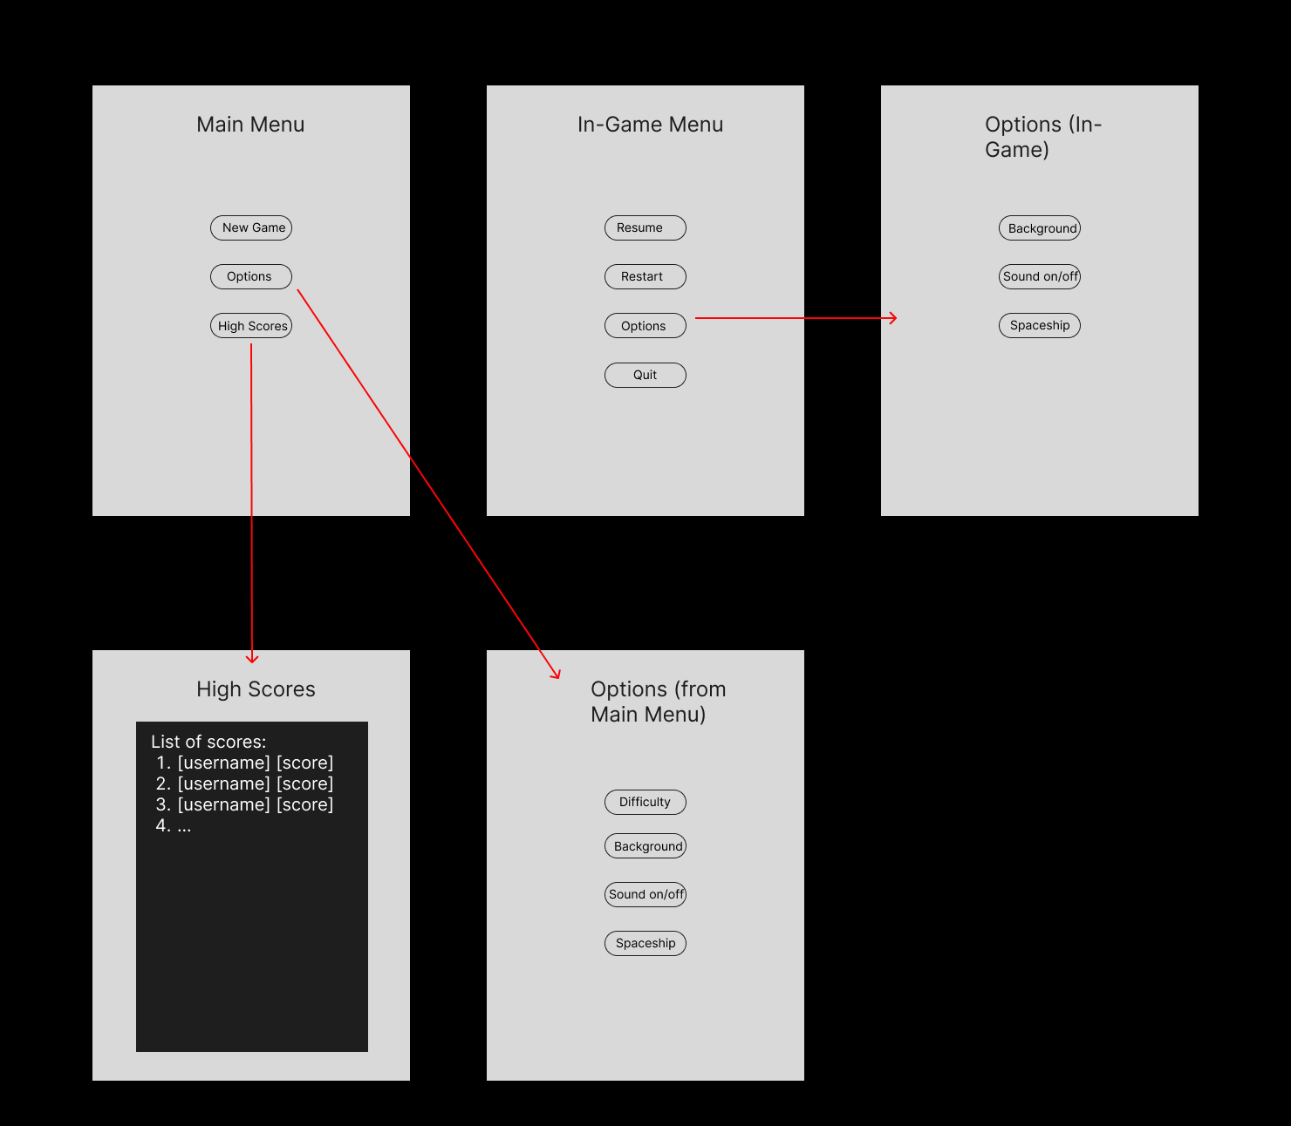

Game layout:

*arrows represent movement directions of enemies, projectiles, the player, and dangerous obstacles (asteroids, etc.)

